Лабораторна робота № 6
Мета: Одержати практичні навички створення та роботи з делегатами
Основний зміст роботи.
Створити декілька делегатів і використати їх для даних різних методів.
Лістинг програми:

using System.Globalization;
using System.Text.Json;
using System.Windows.Forms;
using static System.Windows.Forms.VisualStyles.VisualStyleElement;
using static System.Windows.Forms.VisualStyles.VisualStyleElement.Button;

namespace lr_1_3
{
public partial class Form1 : Form
{
// ====================== ДЕЛЕГАТ ===========================
public delegate int RoomSorter(Room a, Room b);
// ====================== ІНТЕРФЕЙСИ ===========================
public interface IPriceable
{
int Price { get; }
}

public interface IComfort
{
bool Wifi { get; }
bool Food { get; }
string Climate { get; }
string Toilet { get; }
}

public interface IRoomInfo
{
int Seats { get; }
double Area { get; }

int Beds { get; }
string BedType { get; }
string Furniture { get; }
string RoomType { get; }
}

public class Room : IPriceable, IComfort, IRoomInfo
{
public int seats { get; set; }
public double area { get; set; }
public int beds { get; set; }
public string bedType { get; set; }
public string furniture { get; set; }
public bool wifi { get; set; }
public string climate { get; set; }
public bool food { get; set; }
public string toilet { get; set; }
public int price { get; set; }
public string RoomType { get; set; }

// Інтерфейси
public int Price => price;
public bool Wifi => wifi;
public bool Food => food;
public string Climate => climate;
public string Toilet => toilet;

public int Seats => seats;
public double Area => area;
public int Beds => beds;
public string BedType => bedType;
public string Furniture => furniture;

public Room() { }

public Room(int seats, double area, int beds, string bedType, string furniture, bool wifi, string climate, bool food, string toilet, int price)
{
this.seats = seats;
this.area = area;
this.beds = beds;
this.bedType = bedType;
this.furniture = furniture;
this.wifi = wifi;
this.climate = climate;
this.food = food;
this.toilet = toilet;
this.price = price;
this.RoomType = "Standard";
}

public static bool operator ==(Room a, Room b)
{
if (ReferenceEquals(a, b)) return true;
if (ReferenceEquals(a, null) || ReferenceEquals(b, null)) return false;
return a.seats == b.seats;
}

public static bool operator !=(Room a, Room b) => !(a == b);
public static bool operator >(Room a, Room b) => a.price > b.price;
public static bool operator <(Room a, Room b) => a.price < b.price;

public override bool Equals(object obj) => obj is Room r && this == r;
public override int GetHashCode() => seats.GetHashCode() ^ price.GetHashCode();
}

public class LuxuryRoom : Room
{
public string ExtraService { get; set; }
public bool HasBalcony { get; set; }

public LuxuryRoom() { } // ВАЖЛИВО ДЛЯ JSON

public LuxuryRoom(int seats, double area, int beds, string bedType, string furniture, bool wifi,
string climate, bool food, string toilet, int price,
string extraService, bool hasBalcony)
{
this.seats = seats;
this.area = area;
this.beds = beds;
this.bedType = bedType;
this.furniture = furniture;
this.wifi = wifi;
this.climate = climate;
this.food = food;
this.toilet = toilet;
this.price = price;

this.ExtraService = extraService;
this.HasBalcony = hasBalcony;
this.RoomType = "Luxury";
}
}

public class EconomyRoom : Room
{
public bool SharedToilet { get; set; }

public EconomyRoom() { }

public EconomyRoom(int seats, double area, int beds, string bedType, string furniture, bool wifi,
string climate, bool food, string toilet, int price,
bool sharedToilet)
{
this.seats = seats;
this.area = area;
this.beds = beds;
this.bedType = bedType;
this.furniture = furniture;
this.wifi = wifi;
this.climate = climate;
this.food = food;
this.toilet = toilet;
this.price = price;

this.SharedToilet = sharedToilet;
this.RoomType = "Economy";
}
}
// ====================== АГРЕГАЦІЯ ===========================
private Hotel hotel = new Hotel("Podillya");
private Logger logger = new Logger();

public Form1()
{
InitializeComponent();
panel1.Hide();
label28.Hide();
// ----- Підписка на події -----
hotel.RoomAdded += r => logger.Log($"Додано: {r.RoomType}, {r.price} грн");
hotel.StatusMessage += msg => logger.Log(msg);

dataGridView1.DefaultCellStyle.WrapMode = DataGridViewTriState.True;
dataGridView2.DefaultCellStyle.WrapMode = DataGridViewTriState.True;
dataGridView1.Columns.Add("Type", "Type");
dataGridView1.Columns.Add("Seats", "Seats");
dataGridView1.Columns.Add("Area", "Area (m²)");
dataGridView1.Columns.Add("Beds", "Beds");
dataGridView1.Columns.Add("BedType", "Bed type");
dataGridView1.Columns.Add("Furniture", "Furniture / Tech");
dataGridView1.Columns.Add("WiFi", "Wi-Fi");
dataGridView1.Columns.Add("Climate", "Climate");
dataGridView1.Columns.Add("Food", "Food");
dataGridView1.Columns.Add("Toilet", "Toilet");
dataGridView1.Columns.Add("Price", "Price (₴)");
foreach (DataGridViewColumn col in dataGridView1.Columns)
{
dataGridView2.Columns.Add((DataGridViewColumn)col.Clone());
}
foreach (DataGridViewColumn col in dataGridView1.Columns)
{
dataGridView3.Columns.Add((DataGridViewColumn)col.Clone());
}
dataGridView1.AutoSizeRowsMode = DataGridViewAutoSizeRowsMode.AllCells;
dataGridView2.AutoSizeRowsMode = DataGridViewAutoSizeRowsMode.AllCells;
}
private void FillGrid(DataGridView grid, List<Room> rooms)
{
grid.Rows.Clear();

foreach (var r in rooms)
{
grid.Rows.Add(
r.RoomType,
r.seats,
r.area,
r.beds,
r.bedType,
r.furniture,
r.wifi ? "Yes" : "No",
r.climate,
r.food ? "Yes" : "No",
r.toilet,
r.price
);
}
}
private void button1_Click(object sender, EventArgs e)
{
try
{
int seats = int.Parse(textBox1.Text);
double area = double.Parse(textBox2.Text);
int beds = int.Parse(textBox3.Text);
string bedType = comboBox1.Text;
string furniture = string.Join("; ", checkedListBox1.CheckedItems.Cast<string>());
string climate = string.Join("; ", checkedListBox2.CheckedItems.Cast<string>());
bool wifi = checkBox1.Checked;
bool food = checkBox2.Checked;
string toilet = comboBox2.Text;
int price = int.Parse(textBox4.Text);
string roomType = comboBox3.Text;

Room r;

if (roomType == "Luxury")
{
r = new LuxuryRoom(seats, area, beds, bedType, furniture, wifi, climate, food, toilet, price, "SPA, Mini-bar", true);
}
else if (roomType == "Economy")
{
r = new EconomyRoom(seats, area, beds, bedType, furniture, wifi, climate, food, toilet, price, true);
}
else
{
r = new Room(seats, area, beds, bedType, furniture, wifi, climate, food, toilet, price);
}
r.RoomType = roomType;
hotel.AddRoom(r);

int v = dataGridView1.Rows.Add(
r.RoomType,
r.seats,
r.area,
r.beds,
r.bedType,
r.furniture,
r.wifi ? "Yes" : "No",
r.climate,
r.food ? "Yes" : "No",
r.toilet,
r.price
);

MessageBox.Show($"{roomType} room added!");
textBox1.Clear();
textBox2.Clear();
textBox3.Clear();
textBox4.Clear();
comboBox1.SelectedIndex = -1;
comboBox2.SelectedIndex = -1;
comboBox3.SelectedIndex = -1;
checkBox1.Checked = false;
checkBox2.Checked = false;
for (int i = 0; i < checkedListBox1.Items.Count; i++)
{
checkedListBox1.SetItemChecked(i, false);
}
for (int i = 0; i < checkedListBox2.Items.Count; i++)
{
checkedListBox2.SetItemChecked(i, false);
}
}
catch
{
MessageBox.Show("Check entered data!");
}
}
private void вивестиToolStripMenuItem_Click(object sender, EventArgs e)
{
panel1.Show();
label28.Show();
}

private void label28_Click(object sender, EventArgs e)
{
panel1.Hide();
label28.Hide();
}

private void зберегтиToolStripMenuItem_Click(object sender, EventArgs e)
{
SaveFileDialog save = new SaveFileDialog();
save.Filter = "JSON Files (*.json)|*.json";
save.Title = "Зберегти таблицю";

if (save.ShowDialog() == DialogResult.OK)
{
try
{
// Зберігаємо список кімнат у JSON форматі
string json = JsonSerializer.Serialize(hotel.Rooms, new JsonSerializerOptions { WriteIndented = true });
File.WriteAllText(save.FileName, json);

MessageBox.Show("Файл успішно збережено!", "Збереження", MessageBoxButtons.OK, MessageBoxIcon.Information);
}
catch (Exception ex)
{
MessageBox.Show("Помилка при збереженні: " + ex.Message);
}
}
}

private void створитиToolStripMenuItem_Click(object sender, EventArgs e)
{
OpenFileDialog open = new OpenFileDialog();
open.Filter = "JSON Files (*.json)|*.json|All Files (*.*)|*.*";
open.Title = "Відкрити таблицю";

if (open.ShowDialog() == DialogResult.OK)
{
try
{
string json = File.ReadAllText(open.FileName);
List<Room>? loadedRooms = JsonSerializer.Deserialize<List<Room>>(json);

if (loadedRooms == null || loadedRooms.Count == 0)
{
MessageBox.Show("Файл порожній або некоректний!");
return;
}

hotel.Rooms = loadedRooms;
dataGridView1.Rows.Clear();

foreach (var r in hotel.Rooms)
{
dataGridView1.Rows.Add(
r.RoomType,
r.seats,
r.area,
r.beds,
r.bedType,
r.furniture,
r.wifi ? "Yes" : "No",
r.climate,
r.food ? "Yes" : "No",
r.toilet,
r.price
);
}

MessageBox.Show("Файл успішно відкрито!");
}
catch (Exception ex)
{
MessageBox.Show("Помилка при відкритті: " + ex.Message);
}
}
}

private void button2_Click(object sender, EventArgs e)
{
dataGridView2.Rows.Clear();

if (string.IsNullOrWhiteSpace(textBox5.Text))
{
MessageBox.Show("Введіть кількість місць!");
return;
}

if (hotel.Rooms.Count == 0)
{
MessageBox.Show("Немає даних!");
return;
}

int seats = int.Parse(textBox5.Text);
var filteredRooms = hotel.Rooms.Where(r => r.seats == seats).ToList();

if (filteredRooms.Count == 0)
{
MessageBox.Show("Кімнати з такою кількістю місць не знайдено!");
return;
}

foreach (var r in filteredRooms)
{
dataGridView2.Rows.Add(
r.RoomType,
r.seats,
r.area,
r.beds,
r.bedType,
r.furniture,
r.wifi ? "Yes" : "No",
r.climate,
r.food ? "Yes" : "No",
r.toilet,
r.price
);
}

if (filteredRooms.Count >= 2)
{
if (filteredRooms[0] > filteredRooms[1])
MessageBox.Show("Перша кімната дорожча за другу!");
else if (filteredRooms[0] < filteredRooms[1])
MessageBox.Show("Перша кімната дешевша за другу!");
else
MessageBox.Show("Ціни кімнат однакові!");
}
else
{
MessageBox.Show("Знайдено лише одну кімнату!");
}
}

private void dataGridView2_CellContentClick(object sender, DataGridViewCellEventArgs e)
{

}
private List<Room> SortRooms(List<Room> rooms, RoomSorter sorter)
{
List<Room> result = new List<Room>(rooms);

for (int i = 0; i < result.Count - 1; i++)
{
for (int j = i + 1; j < result.Count; j++)
{
if (sorter(result[i], result[j]) > 0)
{
var tmp = result[i];
result[i] = result[j];
result[j] = tmp;
}
}
}

return result;
}
private void button3_Click(object sender, EventArgs e)
{
if (dataGridView1.Rows.Count == 0)
{
MessageBox.Show("Немає даних для сортування!");
return;
}

List<Room> list = new List<Room>();

// Зчитуємо з dataGridView1 → список Room
foreach (DataGridViewRow row in dataGridView1.Rows)
{
if (row.IsNewRow) continue;

Room r = new Room()
{
RoomType = row.Cells[0].Value?.ToString(),
seats = int.Parse(row.Cells[1].Value.ToString()),
area = double.Parse(row.Cells[2].Value.ToString()),
beds = int.Parse(row.Cells[3].Value.ToString()),
bedType = row.Cells[4].Value.ToString(),
furniture = row.Cells[5].Value.ToString(),
wifi = row.Cells[6].Value.ToString() == "Yes",
climate = row.Cells[7].Value.ToString(),
food = row.Cells[8].Value.ToString() == "Yes",
toilet = row.Cells[9].Value.ToString(),
price = int.Parse(row.Cells[10].Value.ToString())
};

list.Add(r);
}

// --- ВЛАСНИЙ ДЕЛЕГАТ ---
RoomSorter sorter = (a, b) => a.price.CompareTo(b.price);

// --- НАША РЕАЛІЗАЦІЯ СОРТУВАННЯ ---
List<Room> sorted = SortRooms(list, sorter);
ф
FillGrid(dataGridView3, sorted);

MessageBox.Show("Відсортовано делегатом за ціною!");
}

private void button4_Click_1(object sender, EventArgs e)
{

if (dataGridView1.SelectedRows.Count == 0)
{
MessageBox.Show("Виберіть рядок для видалення!");
return;
}

int index = dataGridView1.SelectedRows[0].Index;

if (index >= hotel.Rooms.Count)
{
MessageBox.Show("Помилка видалення!");
return;
}

hotel.Rooms.RemoveAt(index);
dataGridView1.Rows.RemoveAt(index);

MessageBox.Show("Кімнату видалено!");
}
}
}
Результат
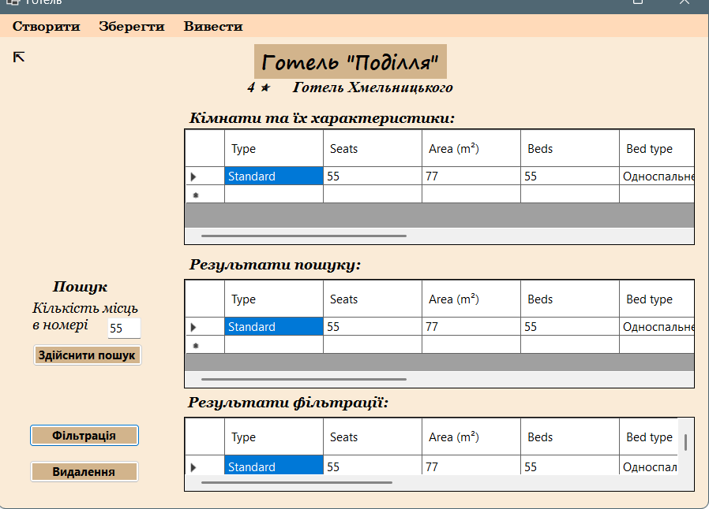
Здійснює фільтрацію за ціною
А також є можливість видалити кімнату при натисканні на рядок в Datagrid1
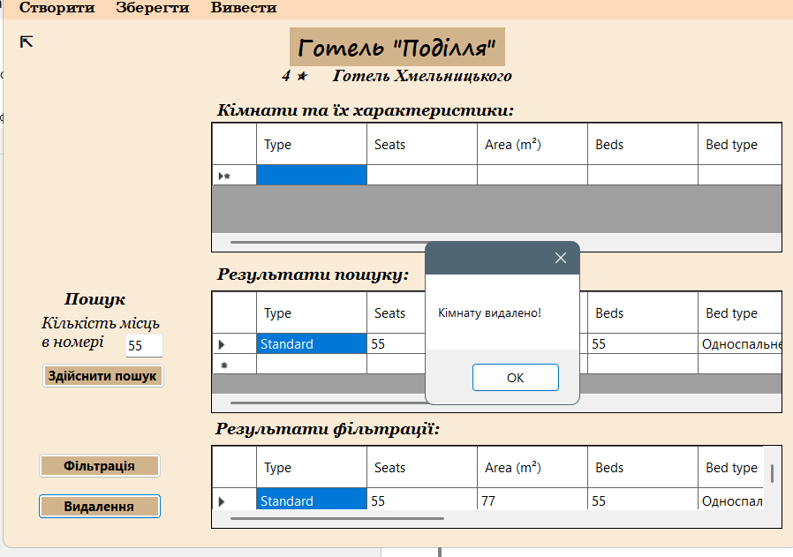
Висновок: Одержала практичні навички створення та роботи з делегатами

